Tanami RBM Database

System Documentation
Version 1.0

Document History
Date | Author | Version | Summary of changes
4/2/16 | Thalie Partridge | 0.1 | Document created. Additional information required re information tables, queries, macros
5/4/17 | Thalie Partridge | 0.2 | .cv exports created and imports repaired by Mosheh Eliyaho from TERN/University of Adelaide.  More detail described for imports/exports and key tables.  Fixed some basic consistency within forms eg moved Wetland Birds page next to Bird Obs and Tracking Obs last. Some better alignment of summary/extract buttons within each form. (basic changes not updated in screenshots)
13/7/2017 | Thalie Partridge | 0.3 | Reviewed by Claire Treilibs  Final repairs and data imports identified a number of additional issues which have been updated in the documentation.  Two systems created. Full version and version for sharing publicly with location and personal information denatured.

Table of Contents
Introduction 4
Purpose of this document 4
Background 4
System Scope 4
System Users 5
Workflow 6
Create a survey 8
Survey sites 9
Site details 10
Vegetation transects 11
Vegetation Transect sheet 12
Fauna records, Bird Observations and Wetland Birds 13
Fauna record sheet 13
Tracking Observations 14
Tracking observation sheet 14
Information Tables 15
Survey/Start page 15
Survey sites 15
Vegetation Transects 15
Data import: Append_veg 15
Process new veg: Append transects 15
Error checking 16
Fauna Records 16
Bird Observations 16
Wetland Birds 16
Tracking Observations 16
Data summaries 17
Entity Relationship Diagram 18

Introduction

Purpose of this document
This document describes the Tanami Regional Biodiversity Monitoring (TRBM) Database V8 which was developed for and holds biodiversity data collected as part of the TRBM project.

Background
The TRBM project was established in 2005 in conjunction with Newmont Tanami Pty Ltd in the central and northern Tanami, Northern Territory. The project collected biodiversity information to inform conservation strategies in the Tanami, particularly in relation to existing and future mining operations. Eight surveys were undertaken between 2005 and 2012 across 89 sites.
Central Land Council staff developed a MS Access database in 2005 to manage flora and fauna data. No documentation was created at the time and unstructured developed has impacted on the database structure. This documentation may therefore be incomplete. Following a system review broken data import processes were found to be caused by an upgrade of Microsoft Access. Imports were repaired, a number of new .csv exports were created and the database was upgraded to .accdb in December 2016 with the assistance of Matt Schneider and Mosheh Eliyahu from the Terrestrial Ecological Research Network, Ecoinformatics, University of Adelaide.
Repairs were only implemented for import and export processes. Where possible, remaining system issues are identified in this document. If Tanami RBM surveys are continued these issues should be resolved.

System Scope
The system is limited to the following functionality:
- The repaired database can be opened in any Access version newer than 2003 (i.e. Access 2007, 2010, 2013 or 2016)
- No user login or system security
- The system does not link to data from other sources
- MS Access form interface
- Tables, queries and macros are accessible via the navigator pane for advanced users
- General users can:
  - Edit species scientific and common names
  - Add or edit staff, survey and site information
  - Add or edit species observations in a form
  - Import large datasets from Excel spreadsheets
  - Run error checking processes to find missing vegetation data
  - Export data extracts as a .csv file.
  - Generate a summary of sites showing survey data entered (or required)
  - Generate species lists by site or taxa

System Users
The following table identifies the roles and interest of different stakeholders in the TRBM Database
Role | Who | Contribution/Interest | System Use
TRBM project coordination | Regional Land Management Officer (Tanami), CLC | Coordinate logistics and funding, employ consultants, prepare reports, participate in fieldwork | - Add new project sites  - Add data  - View and extract data summaries  - Approve access to data
Field coordination | NT/STIPA Officers  NT/STIPA Ranger Coordinators  Traditional owners | Facilitate fieldwork and field staff | - Collect data  - View and extract data summaries
Field implementation | NT/ST Rangers,  Traditional owners | Implement field activities | - Collect data  - View and extract data summaries
Database management | Land Resource Information Officer | Review data collection methods, coordinate data management | - Supervise data entry and extraction  - Review and edit framework data (eg scientific names)  - Train staff in use of system  - Identify additional user needs  - Manage system maintenance activities  - Version control  - Provide advice on data sharing
Environmental Consultants | Low Ecological Services | Expert scientific advice, project development, survey methods, supervise field workers, implement and review field activities, prepare reports, undertake data entry and quality control. | - Collect data  - Transcribe data from datasheets into spreadsheets for upload to database  - Enter data into database  - Review and edit data  - View and extract data summaries
Landowner | CLC and traditional owners | Approve project activities | - Review an annual update on progress of project  - Access to data summaries  - Data owner
Investor/Land user | Mining companies | Project funding, logistical support, data required to meet legislative requirements | - Review an annual update on progress of project  - Access and rights to use data  - Copy of database should be provided on an annual basis
Data user | NT Govt, Aust Govt,  Consultants, university researchers | Access to data for multiple purposes e.g, EIS activities, biodiversity analysis, species projects, research on management | - Access to CC by open data through AEKOS  - Access to licenced data on application to Central Land Council
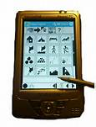
The following diagram illustrates the basic user/system interface.
CSV
TRBM database

Workflow
The current data entry process occurs through an MS Access database interface that allows a single user. The following sections show screenshots and describe each workflow:
- create a survey and survey sites;
- add and edit vegetation, fauna, bird, tracking and wetland bird observations.
The system allows for manual addition of survey, staff and site information and species observations. Each section has a new, delete and edit button. There is a ‘view’ button but its development was never completed. You can view data through the ‘edit’ button.
The system has the ability to import and process large species observation datasets from MS Excel and then run error checking to identify missing data.
The system also allows the general user to edit species lists. These do not automatically update data in site observation sheets but will impact species names in data extracts. The tracking_species table informs species recorded in tracking observations but is not linked to the primary fauna species list so will not be affected by edits.
The system allows the ‘edit’ or addition of incidental observations.
Exports on each major form create a .csv extract of all the data. Some allow you to extract by survey or to extract just a species list.

Collect data
Add data to CyberTracker
Add data to Excel

TRBM DATABASE
Manage (create) Survey
Edit Staff list
Incidental Species Observation
Edit species list
Extract list of sites requiring data
Add site details
Vegetation Transects (import and process)
Fauna Records
Bird Observations
Tracking Observations (import and process)
Wetland Birds
Extract full list of plant species
For each group, extract full species list or by site and extract all data to .csv

Create a survey
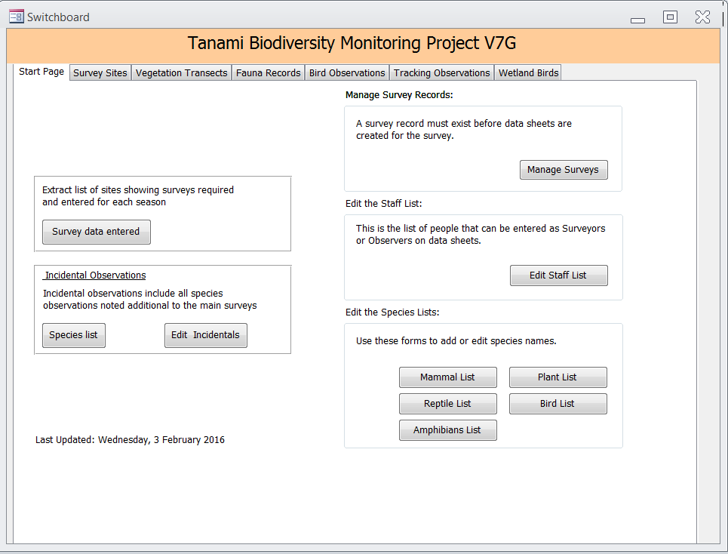

Form actions
- Manage surveys
- Includes edit staff list (Survey_StaffList) and maintain species names (Table Species_Fauna and tblPlantDetails).
- Extract sites requiring data
- Incidental fauna observations
  - Identify nearest site but doesn't have to be in one, has been poorly used, eg site or lat/long not always entered
  - Allows anything to be written into species name, ideally should be linked to other fauna lists and require to be pulled from dropdown.

Survey sites
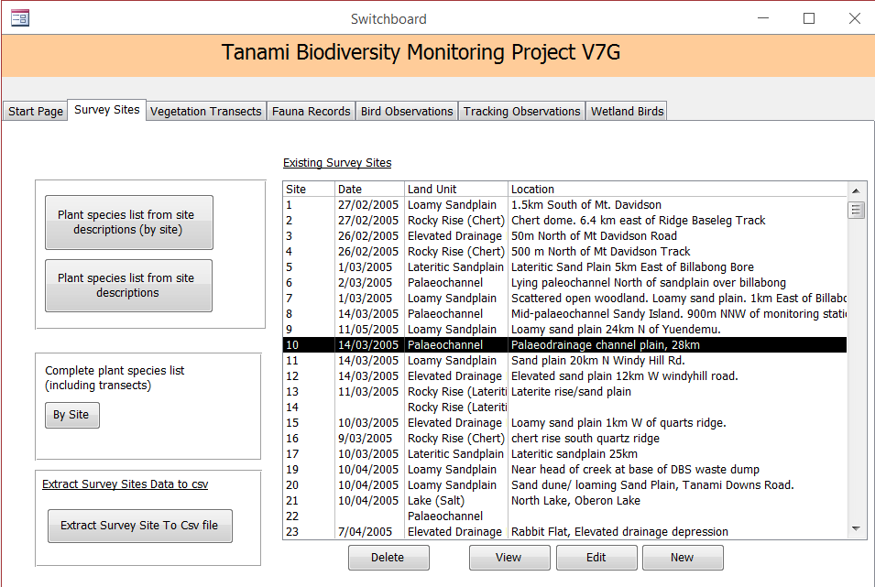

Form actions
  - Add a new site
  - Choose an existing site to edit or delete (note the View button does not work)
  - Extract data

Site details
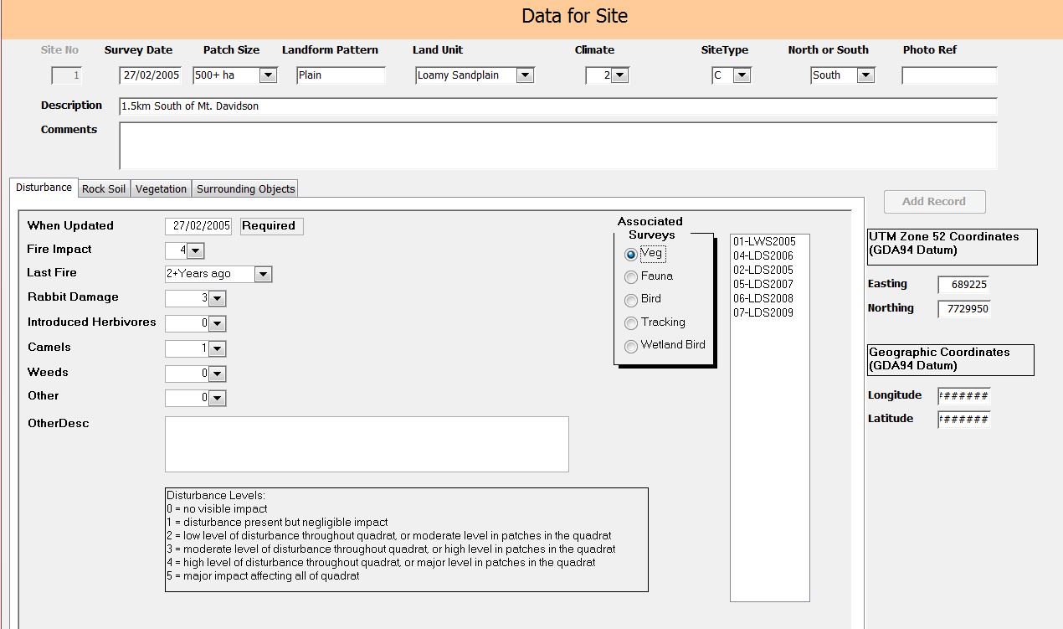

Form actions
- Add a survey site
  - Enter general site information
  - Enter detailed site information: disturbance, rock/soil, vegetation, surrounding objects
  - Allows the user to update site detail information but does not save historic information. This would be an issue if change in disturbance over time were of interest. However, no site details were updated post 2005.
  - Choose a type of Associated Survey (veg, fauna, bird, tracking, wetland bird) to see which Survey they occurred in at the Site. NOTE this appears to be part of each subform but is related to the Site not the subform. Best visibility for Associated surveys is when in the Disturbance subform.
  - When adding a new dominant species for the site the form connects to the tblPlantDetails. In an old version of the database it looked to the table Species_Plants for providing a dropdown choice of species but this broke or was disconnected for some reason.

Vegetation transects
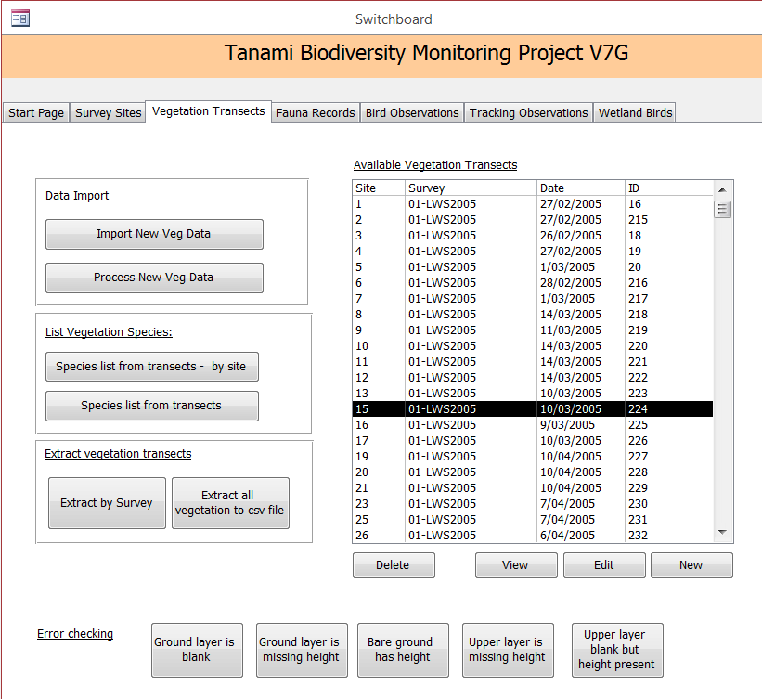

Form actions
  - Add new vegetation transect
  - Edit or Delete selected vegetation transect (note the View button does not work)
  - Import new veg data
    - Some data that can be imported doesn’t appear in the vegetation transect sheet
  - Process new veg data
  - Error checking of veg data
  - Data summaries/extracts (see data summaries and extracts for more detail)
    - Species list by site or full
    - Extract data by survey number
    - Extract all vegetation to csv file

Vegetation Transect sheet
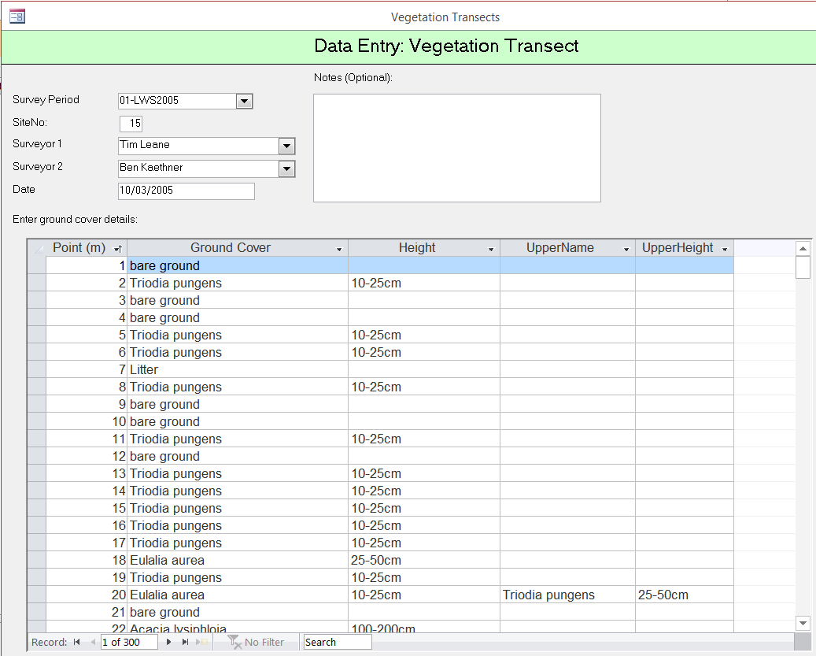

Form actions
  - View and edit data at each point along a transect.
  - Data includes: Transect point, ground cover species name, height, upper species name, upper height

Fauna records, Bird Observations and Wetland Birds
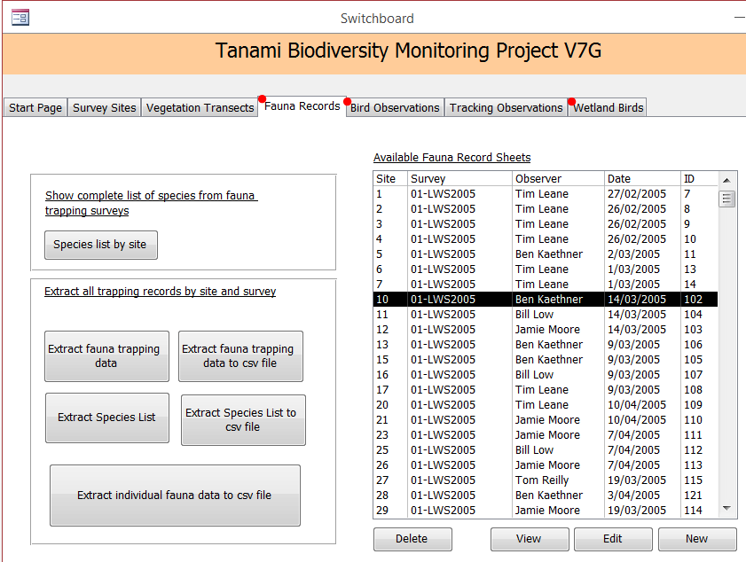

Form actions
  - Add new fauna record sheet
  - Edit and delete selected fauna survey (note the View button does not work)
  - Data summaries/extracts (see data summaries and extracts for more detail)
    - Species list by site
    - Extract fauna trapping data (table view and extract to .csv file)
    - Extract Species List (table view and extract to .csv file)
    - Extract individual fauna data to .csv file

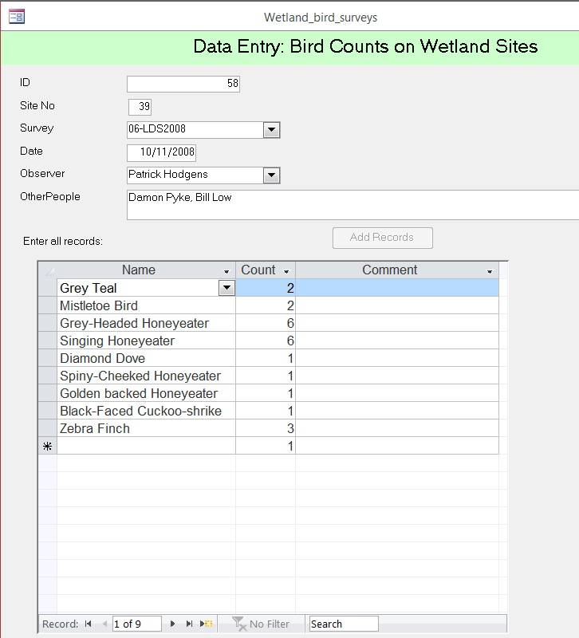
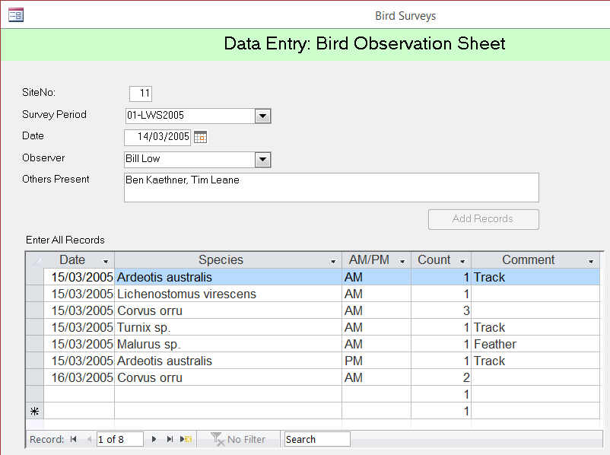
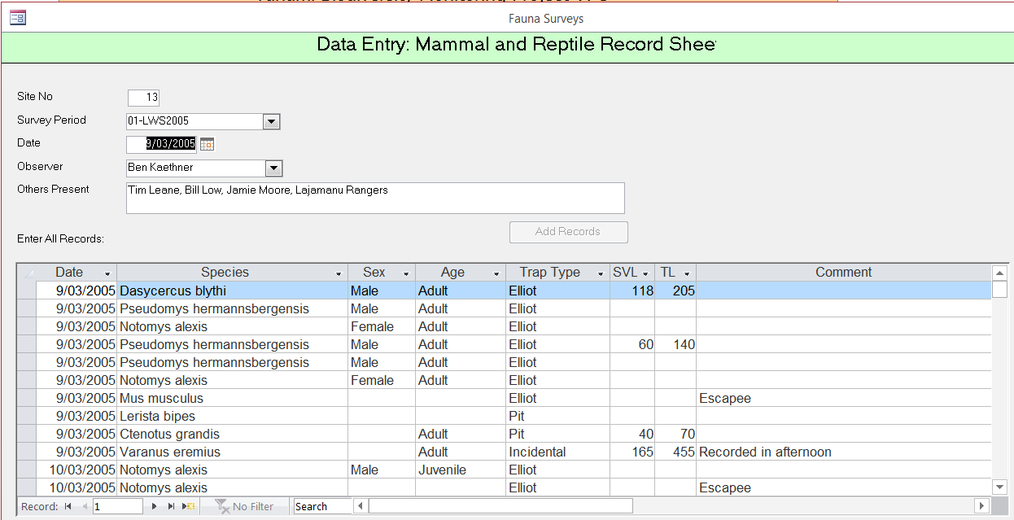
Fauna record sheet

Form actions
  - Add fauna data directly into table
    - Mammal and reptile identifies sex, age, trap type, svl, tl and comments
    - Bird observations identify am/pm, count, comments
    - Wetland birds identify count and comments

Tracking Observations
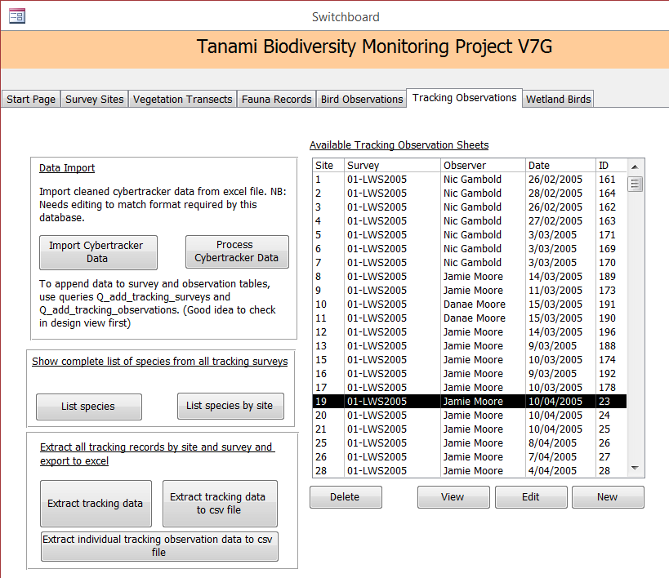

Form actions
  - Add New Tracking Observation Sheet
  - Edit or Delete selected Tracking Observation Sheet (note View button does not work)
  - Import new CyberTracker data
  - Process new CyberTracker data
  - Data summaries/extracts (see data summaries and extracts for more detail)
    - Species list by site or full
    - Extract data by site and survey (form view and extract to .csv)
    - Extract individual tracking observation data to .csv file
Table data sources:
- Survey Period = Surveys
- Surveyor 1 and 2 = Survey_StaffList
- Trackability = Trackability
- Unique data = Tracking_Surveys
- All Records (subform): Tracking_Observations + Tracking_species
Tracking observation sheet
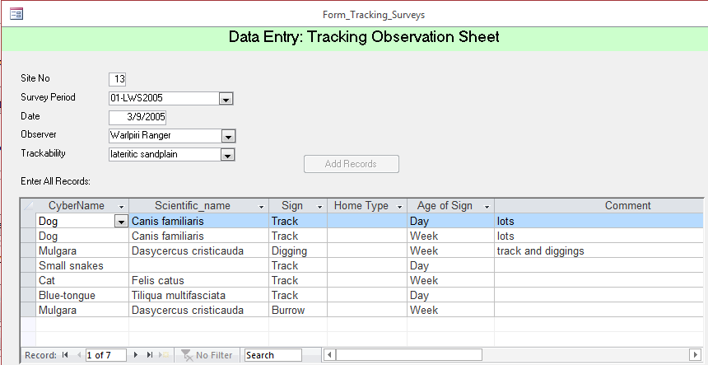

Form actions
  - View and edit tracking observations

Information Tables and Data Extracts
Key tables on each form are described below. This includes tables or datasheet views created by data summary/extract buttons. Some of the extracts were broken following an upgrade of Microsoft Access. These were repaired with the assistance of University of Adelaide/TERN Ecosystematics group. The following describes the main tables for each workflow (including table/data extracts):

Survey/Start page
Event | Table Name | Comments
Manage Surveys | Surveys | This is used to inform a dropdown in survey details in site/veg/fauna forms
Edit Staff List | Survey_StaffList | This is used to inform a dropdown in survey details in site/veg/fauna forms
[Edit] Species Lists (multiple Fauna) | Species_Fauna | Each list uses a query to bring up just that taxa
[Edit] Plant List | tblPlantDetails | used to be called Species_Plants and was changed for some reason which may have affected data in the vegetation section.  Includes a list of uniform species codes based on the CSIRO (1981) system and must be referred to whilst entering data to ensure standardisation. Possible codes changed at some point which could cause issues. Unfortunately the reference (CSIRO 1981) has not been discovered.
Survey data entered | Surveys_entered | Macro creates table from various queries (eg Q = xtract_bird_entered) of Survey tables (eg Bird_Surveys) and required surveys from tblSite (older versions database used duplicate table Survey_Sites, not sure why as data doesn’t get updated in this table. Survey_Sites still has a number of dependencies so could be an issue but not sure implications.)  Note spelling of table name and compare with name of command button (sueveys_entered) and VBA code.
Edit Incidentals | Incidentals | Table ‘Incidentals2009’ has been added to the Table ‘Incidentals’. Could probably delete Table ‘Incidentals2009’.
Species List | Incidentals | Query (Q_list_incidental_species) aligns Incidentals table species names with Species_Fauna species names

Survey Sites/Data for Site
Event | Table Name | Comments
Edit/New | tblSite | 90 site records (98 site numbers – some sites were never visited for logistical reasons)
 | tbldisturbance
 | tblrocksoil
 | tblvegetation  - Site_dominant_species | Note this wasn’t updated post 2005.  Possible that site dominant species were not recorded during vegetation transects.
 | tblSurroundingobjects
Plant species list from site descriptions (plain and by site) | Site_dominant_species  tblPlantDetails | Query pulling out plants from Site dominant species list. This data was not updated post 2005
Complete plant species list | Temp_plants_by_site  (Macro: List_transect_&_ dominant_plants_by_site) | Runs Macro to combine species from Site dominant species and Vegetation Transects. Table based on last time macro was run.
Extract Survey Site to Csv file | Q_extract_survey_site_data | Opens file save window

Vegetation Transects
Event | Table Name | Comments
Edit/New | Vegetation_transects
 | Vegetation_transect_points | Ground Cover Details subform
Species list from transects (plain and by site)  Runs Macro: list_veg_species | Datasheet view of query result either:  all_veg_species_by_site and  Q_list_veg_species | Query across all vegetation transects. NOTE does not include dominant veg species from Site details.
Extract by survey  Runs Query: Select_vegdata_by_Survey | Datasheet view of query result  Vegetation_transects  Vegetation_transect_Points  Surveys | Query across all vegetation transects. NOTE does not include dominant veg species from Site details.
Extract all vegetation to csv file | Datasheet view of query result Q_select_vegdata_all_Surveys | Opens file save window

Fauna Records
Event | Table Name | Comments
Edit/New | Fauna_Surveys
 | Fauna_Records | Enter All Records subform
Extract Species List  Runs Macro:  Q_list_trapping_species | Datasheet view of query result | Includes count of all species recorded
Extract Species List to csv file |  | Opens file save window
Species list by site  Runs Query: Q_list_trapping_species_by_site | Datasheet view of query result  Fauna_Surveys  Fauna_Records  Species_Fauna | Query across all fauna surveys.  Count of each species by site.
Extract fauna trapping data  Runs Macro: Extract_trapping_by_site&survey | Datasheet view of query result  Q_trapping_species_by_survey&site_Crosstab  Which uses Q_trapping_species_by_survey&site  Tables:  Survey_Sites  Surveys  Fauna_Surveys  Fauna_Records | Query across all vegetation transects. NOTE does not include dominant veg species from Site details.
Extract fauna trapping data to csv file |  | Opens file save window
Extract individual fauna data to csv file | Q_extract_individual_fauna_data  Tables:  Survey_Sites  Surveys  Fauna_Surveys  Fauna_Records | Opens file save window  (Similar to query above but extracts more fields, particularly Survey Site fields)

Bird Observations
Event | Table Name | Comments
Edit/New | Bird_Surveys
 | Bird_Observations | Enter All Records subform  Bird_Observations table used a lookup of to force correct species names. It refered to two queries:  Bird_CommonNames then Species_Birds. The latter query refers to Species_Fauna.  In order to mass enter/correct data the combo box/lookup in the Bird_Observations table needed to be changed to list box to allow data to be added, removing the link to the Bird_CommonNames query and any data correction.
Species List  Runs Macro: list_bird_transect_species | Datasheet view of query result  Q_list_bird_transect_species  (Bird_Observations  Species_Fauna) | Query across all bird observation  Count of each species
Extract Species List to csv file |  | Opens file save window
Species list by site  Runs Query: Q_list_bird_transect_species _by_site | Datasheet view of query result  Q_list_bird_transect_species  Tables  Bird_Surveys  Bird_Observations  Species_Fauna | Query across all Bird surveys.  Count of each species by site.
Extract bird list by site to csv file |  | Opens file save window
Extract Individual Birds Data To Csv File  Runs Query:  Q_extract_individual_birds_data | Bird_Surveys  Bird_Observations | Opens file save window

Wetland Birds
Event | Table Name | Comments
Edit/New | Wetland_bird_Surveys
 | Wetland_bird_counts | Enter All Records subform
Species List  Runs Macro:  list_wetland_bird_species | Datasheet view of query result  Q_list_wetland_bird_species  Tables  Wetland_bird_counts  Species_Fauna | Query across all Bird surveys.  Count of each species by site.
Extract bird list by site to csv file |  | Opens file save window
Species List by site  Datasheet view of query result  Q_list_wetland_bird_species _by_site | Tables  Wetland_bird_counts  Wetland_bird_surveys  Species_Fauna | Query across all bird observation  Count of each species
Extract Species List to csv file |  | Opens file save window
Extract Individual Wetland Birds Data To Csv File  Runs Query:  Q_extract_individual_wetland _birds_data | Wetland_bird_counts  Wetland_bird_surveys | Opens file save window

Tracking Observations
Event | Table Name | Comments
Edit/New | Tracking_Surveys | For manual input of tracking surveys (also see import process)
 | Tracking_Observations | Enter All Records subform
Species List  Datasheet view of query result  Q_list_tracking_species | Tables  Tracking_Observations  Tracking_Species | Query across all Tracking surveys.  Count of the number of records of each species
Species List by site  Datasheet view of query result  Q_list_tracking_species_by_site | Tables  Tracking_Observations  Tracking_Species  Tracking_Surveys | Query across all Tracking surveys  Count of the number of records of each species by site
Extract tracking data  Runs Macro:  Extract_tracking_by_site&survey | Datasheet view of crosstab query result  Q_tracking_by_site&survey_ Crosstab  Tables  Survey_Sites  Tracking_Surveys  Tracking_Observations  Surveys | No. of each species recorded by site and survey  Note – tracking data doesn’t necessarily relate to no. of animals but number of times a sign was recorded for a species  Note – uses CyberName not common or scientific name
Extract tracking data to csv file |  | Opens file save window
Extract individual tracking observation data to csv file  Runs Query :  Q_extract_individual_ tracking_observations | Tracking_Surveys  Tracking_Observations  Tracking_Species | Includes sign type information for each record  Opens file save window

Data import
Data import can be done manually for all sections. However, automatic data import processes were established for Vegetation Transects and Tracking Observations. These are described below.

Import New Vegetation Transect Data
The following was recorded in Moon and Low (2006):
‘Whilst most of the data is easily entered, the vegetation survey data entry is the most time consuming process. A more efficient method for entering vegetation has been developed using a code system in excel and the data base program was modified so the excel spreadsheet data can be uploaded into the data base. The code system uses the first two letters of the genus and species names. It is important when using this system to ensure that uniform codes are used throughout and that alternative codes are used for species who’s names create duplicate codes. A list of uniform codes has been based on the CSIRO (1981) system and must be referred to whilst entering data to ensure standardisation.’

Import New Veg Data > runs Macro > Append_veg_transects
Known steps in this process:
- Open Table : veg_transect_for_appending
- Data must be in the same format as this table:

Field Name | Data Type
ID | Autonumber generated on import
Survey | Survey name eg 08-LDS2012
SiteNo | Number
Surveyor1 | First and Second Name (add to Survey_StaffList first)
Surveyor2 | First and Second Name (add to Survey_StaffList first)
Date | Date: dd/mm/yyyy
Point-m | Number
GroundLayer | Species or ground layer code
Height-g | Number
UpperLayer1 | Species code
Height-u1 | Number
UpperLayer2 | Species code
Height-u2 | Number
UpperLayer3 | Species code
Height-u3 | Number

- veg_transect_for_appending Table retains data from the last import. The macro identifies this and decides whether to delete records
  - SelectAllRecords
  - Delete Record
  - Close Table - veg_transect_for_appending
  - And prompt for save
- Run Import command (ImportAttachExcel)
- Run/Open query: Q_plants_add_species_names
  - The query is joining species name information with species code data from veg_transect_for_appending and tblPlantDetails/Lookup_VegHeightClasses

Process new veg > Append transects
Known steps in this process:
- Runs a series of queries to add information from veg_transect_for_appending to Vegetation_Survey and Vegetation_Transect_Points

- Q_append_veg_transect =
- veg_transect_for_appending + Surveys

- Q_append_veg_points =
- Q_plants_add_species_names + Vegetation_Transects

- Q_plants_add_species_names =
- veg_transect_for_appending + Plant_checklist + Lookup_VegHeightClasses

Error checking
To be run after New Vegetation Transect data has been imported and processed.
Buttons:
- Ground layer is blank = Q - Error_groundlayer_blank
- Ground layer is missing height = Q - error_groundlayer_veg_missing_height
- Bare ground has height = Q - error_bareground_with_height
- Upper layer is missing height = Q - Error_upperlayer_present_no_height
- Upper layer blank but height present = Q - Error_upper_height_present
Event:
- When each query above is run you are asked to choose a survey number
- Looks at the query Select_vegdata_by_Survey which combines data from tables:
  - Surveys
  - Vegetation_Transects
  - Vegetation_Transect_Points
- Query identifies whether data is null or not null
- Displays table with incorrect data allowing you to correct it.

Import new Tracking Observations
The following was recorded in Moon and Low (2006):
‘CyberTracker software has been used to develop a data collection screen sequence for vegetation surveys that may be used on a Dell Mobile PocketPC. CyberTracker software is free-greenware that can gather and map an unlimited amount of ecological data. CyberTracker is currently used by CLC to gather tracking data and has the potential to be developed to collect trapping data, bird counts and wetland bird census data, site descriptions and tree health data. Furthermore, the RBM database has been designed to directly upload output from CyberTracker. The use of CyberTracker will significantly reduce time required for data entry, especially with regards to vegetation data and will standardise data collection between individuals and over time.
It is important that the CyberTracker program be tested thoroughly prior to use in the field to ensure that data is saved correctly and that output data is formatted so that it compatible with direct upload into the RBM data base. CyberTracker will be operational to collect vegetation data prior to commencement of the Late Wet Season 2007 survey. It is intended that it be also operational for collecting site descriptions, trapping and bird data for the next survey, but this will be subject to time and program developmental constraints.’
Development of CyberTracker sequences for data collection has not been developed for other survey methods. As of April 2017 Central Land Council is still using the CyberTracker system but issues with user experience and stability of the system means alternative data collection tools are being assessed.

Import CyberTracker Data
- Open Table : 1_tracking_data_to_append
- Data must be in the same format as table below, however, only the highlighted cells are imported.
- There must be a name in the Observer field or the data won’t be imported correctly.
- Ensure all species names to be imported are in the Tracking_species table
Field Name | Data Type
ID | Autonumber generated on import
Date | Date: dd/mm/yyyy
Time | Time: Short Text
Latitude | Number
Longitude | Number
Observer | In some cases Ranger Group has been used.
Survey | Survey name eg 08-LDS2012
SiteNo | Number
NumberPeople | Number
Trackability | Short text
AnimalGroups | Align with groups in database?
Species | Cyber name
SignType | Short text
BagNumber | Number?
HomeActivity
SignAge | Short text
Photo | ?
ScatType
ScatAge
Notes – Comment

- 1_tracking_data_to_append Table retains data from the last import. The macro identifies this and decides whether to delete records
  - SelectAllRecords
  - Delete Record
  - Close Table - 1_tracking_data_to_append
  - And prompt for save
- Run Import command (ImportAttachExcel)

Process CyberTracker data
Database has a note to check the table and queries in design view first before running the Process.
Known steps in this process:
- Runs a series of queries to add information from 1_tracking_data_to_append to Tracking_Survey and Tracking_Observations

- Q_add_tracking_surveys
  - Identifies the data fields to be added to Tracking_Survey table
- Q_cybertracker_observations
  - Identifies the observation data fields to be added to Tracking_Observations table for each survey.
NOTE: Some site or observation duplication errors have been detected following an import, the cause is unknown. The processed data should be compared with the original import file.

Entity Relationship Diagram
Relationships between key tables are shown below. It doesn’t show all tables or all relationships. There are a number of unnecessary relationships eg between site disturbance, rocksoil, surrounding objects and dominant vegetation values which have been added into the survey tables for each survey method (Birds, Fauna, Wetland birds and Tracking) and then related back to the core Site table (tblSite).

Entity Relationship Diagram
